2.3. Labour Market

Impact of performance decrease on labour market
- Unemployment growth was the highest ever in the history of the Czech Republic |  | Unemployment increased very sharply in 2009; the growth rate was the highest in the entire period of monitoring. The absolute unemployment growth was also reflected in the relative figures; the general unemployment rate among 15 to 64-year old persons in 2009 was 6.8% on average, with a year-on-year increase by 2.4 percentage points. On a quarter-to-quarter basis, however, the seasonally adjusted rate started growing in the 4th quarter of 2008 already and, on contrary, slowing down since the 3rd quarter of 2009. The unemployment rate was lower than both the EU-27 average and the EMU average, but higher than in Denmark (with flexible labour market), the Netherlands, Austria and Germany (with low wage growth).  A predominant part of persons in the group 15 years and older, who were unemployed for less than a year in 2009, comprised persons who lost their job during the year (75%). The second largest group of persons unemployed for less than a year were graduates (11%). Share of persons, who were in household, on maternity and parental leaves, reached 8% of this group of unemployed. The level of long-term unemployed reached 105 thousand persons in 2009. At the same time, regional differences in unemployment increased again, as documented in the attached cartogram of registered unemployment from to the Ministry of Labour and Social Affairs.
Graph No. 2.3.1 | Unemployment (in thousands of persons) |  | Graph No. 2.3.2 | Unemployment rate (in %)
Source: CZSO |  |  | Source: CZSO
Decreasing share of long-term unemployment still represents large numbers of persons |  | The numbers of long-term unemployed have remained at a relatively high level since 2000. It was higher than the EU-15 average, although lower than in Poland and Slovakia. The numbers declined significantly in 2007, and the long-term unemployment rate declined, for the first time, below half of the total (falling) unemployment (48.6%) in the 4th quarter of 2007. This share continued decreasing in 2009 to 29.3% in the 4th quarter. However, the reason behind this is rather the fast growing denominator in the ratio, the total unemployment. At the close of the year, the numbers of long-term unemployed increased slightly again.
Decreased employment and its structure
- Employment in 2009 on a downward trajectory |  | Following three years of continuous growth, employment in the age group of 15 years and older decreased in 2009 by 1.4% on a year-to-year basis. Employment growth, after seasonal adjustment, slowed down quarter-on-quarter from the maximum in the 3rd quarter of 2007 (2.2%) to nearly stagnation in the 4th quarter of 2008. In 2009 on contrary, the decrease in the employment was slowing down on a quarter-to-quarter basis. The average employment thus reached 4,934.3 persons in 2009. The employment rate followed a similar trend, but it has long been above the EU-15 average.  An international comparison must, however, also take into account the length of working hours, which was higher in the Czech Republic than in other European countries. There were three causes: the relatively high share of entrepreneurs in total employment who report a higher number of hours spent at work, the relatively high share of overtime hours worked (particularly by men), as well as the relatively low share of part-time work (especially for women). The average number of weekly hours worked was 38.3 hours (36.9 hours in the processing industry) in 2008, but only 37.4 hours in 2009 (35.7 in the processing industry), as one of the first responses to the decreased demand for labour.  The share of persons working part time in total employment has been rather stagnating after 2000. In international comparison, however, the share of part-time working women was extremely low in the Czech Republic – it amounts to just roughly one-sixth of the EU-15. Part-time work is actually the solution giving a possibility to better reconcile the interests of some persons (especially women, who take care of little children) as well as employers. While 2008 was approximately at the long-tem level, in 2009 the share of part-time jobs increased with the total employment decreasing.
- Changes in the structure of economically active individuals |  | While the total economic activity rate has long been slightly decreasing, it was decreasing more significantly in the group of 15 to 24-year old due to the growing number of students. In the group of persons above 55 years of age, on contrary, the economic activity rate has been growing since 2000 as a result of the gradually increasing retirement age. The activity rate of persons above 55 years of age in the EU-15 countries was also rising sharply. In the Czech Republic, the year of 2008 was approximately at the trend level of these long-term changes. In 2009, the total economic activity rate of 15 to 64-year old persons declined by 1.2 percentage points, but that of 20 to 24-year old persons dropped by 3.1 percentage points; the decrease in other age groups was lower than the average.  The decrease in the number of employees by 87.1 thousand persons against the 2008 average as well as the increase in the number of entrepreneurs in main employment by 22.8 thousand persons indicate a substantial change in the structure of economically active individuals.
Graph No. 2.3.3 | Economic activity rate (in %) |  | Graph No. 2.3.4 | Share of individuals in part-time work (in %)
Source: CZSO |  |  | Source: CZSO
 |  | In the period 2000–2008, the share of employees with higher education and the share of employment in the secondary sector, particularly in the processing industry, were rising. In the 4th quarter of 2008, however, the employment growth in this sector slowed down, while the number of employees in the processing industry even decreased. Employment in the secondary sector declined by 124.1 thousand persons in 2009; at the same time, employment in the tertiary sector increased by 60.8 thousand.

Main factors of the labour market developments
- Contradictory changes on the demand and supply sides | The changes in the numbers of employed and unemployed reflect not only the interaction of these two groups, but also the interaction with the demographic development and changes in the number of economically inactive persons. In this respect, the previous years during the analysed period were characterized by concurrence of several favourable effects.  The increase in demand for goods and services until 2008 caused the employment to grow. Naturally, its growth was not identical to the GDP growth since labour productivity increased as well. The year of 2007 was exceptional in this respect because the contribution of employment to the GDP growth was the highest since the beginning of the analysed period. At the close of 2008, however, it already became apparent that the demand was weakening.  The supply side was under the influence of demographic factors, which slowed down its growth. The “incoming” age group of population (20 – 24 years) was diminishing in numbers since 2000, while the “departing” age group (60 – 64 years) was gradually becoming stronger. In 2008, both tendencies were practically equal so that the growth of such defined potential supply came to a stop, to be even followed by a slight decrease in 2009. The demographic development mitigated the impact of the crisis on the labour market, but was modified – as already mentioned above – by two contradictory social factors: the slow-down of potential supply was compounded by the growing number of students and of women who were temporarily economically inactive. On contrary, the supply was enhanced by the numbers of working individuals over 55 years of age and working foreigners. The long-run tendencies remained without change in 2009, except for the forced decrease in labour supply by foreigners.

Graph No. 2.3.5 Supply and demand on the labour market (demographic changes in thousands of individuals, position as per July 1st)
Source: CZSO
- Structural imbalance on the labour market replaced with symptoms of overall imbalance |  | For long years, the labour market was characterized by a structural imbalance. Since 2004, the growing number of foreigners filled primarily jobs that were not suitable for the domestic supply with regard to profession or wage level, and the employment was growing. On the other side, the unemployed did not make use of all job vacancies in view of the structure that did not match the qualification of the unemployed (demand), and the unemployment did not decline proportionately to the growth of jobs; the number of job vacancies was rising.  In 2009, the relationships changed completely under the impact of the crisis. In the 4th quarter, unemployment increased year-on-year by approximately 150 thousand persons, although the number of foreigners registered with the employment offices decreased by 50 thousand persons. The numbers of job vacancies recorded a substantial fall to 30.9 thousand (year-on-year decrease by 60 thousand jobs). The structure imbalance on the labour market developed into an overall imbalance.
Graph No. 2.3.6 | Foreigners (based on position at work, in thousands of individuals) |  | Graph No. 2.3.7 | Job vacancies (as December 31st, in thousands) and share of applicants per vacancy
Source: Ministry of Labour and Social Affairs, Ministry of Industry and Trade |  |  | Source: Ministry of Labour and Social Affairs
Labour market and wage development
- Average nominal wage increased in 2009 as well |  | The average gross nominal wage (based on FTE numbers of employees in the entire national economy) increased by 4.0% in 2009 based on the labour statistics figures, i.e. the least in the past ten years. However, the growth of nominal and real wage converged thanks to the low inflation so that the average wage, in real terms, grew even faster than in 2008.  This exceptional growth during a crisis is explained by certain structural effects: the number of persons with below-average wage decreased because of their redundancies, the registered sickness rate declined, and the bonuses paid went up in response to the legislative changes. The volume of wages paid decreased, on a year-to-year basis, significantly less (by 2.1%) than the employment (by 5.9%).  The 2009 growth of the average wage, as an approximation of the growth in average price of work, indicates that it was necessary to save elsewhere on labour costs, by reducing employment, in order to maintain or even increase the wages. With regard to the known rigidity of the labour market, however, this step had its time path; in the beginning, employees were forced to cut down the number of hours worked, then there were redundancies of the most vulnerable participants on the labour market, i.e. agency workers and foreigners as a whole, to finally end with closing down of entire plants. On contrary, the high redundancy costs (severance payments) held the unemployment growth back.
Graph No. 2.3.8 | Average nominal and real monthly wage (year-on-year change in %) |  | Graph No. 2.3.9 | Growth of total hourly labour costs (nominal, year 2000=100)
Source: CZSO |  |  | Source: Eurostat
- Wage differentiation is growing |  | The average nominal wage in the business sector (where there were more redundancies) increased by 3.8% to 23,411 CZK, i.e. slower than in the non-business sector where it increased by 4.7% to 24,433 CZK. The gaping difference between the sectors is a longer-term aspect and it is influenced, among others, by a higher share of university graduates employed in the non-business sector, i.e. persons with a higher-than-average wage).  The wage differentiation across branches increased as well. The sharpest wage decrease in 2009 was recorded in mining and quarrying and in hotels, catering and restaurants. On contrary, the largest wage increase was recorded in generation and distribution of electricity, gas, heat and conditioned air, followed by real-estate activities, as well as in health care and social services. Coefficient of variation of average wages (based on CZ-NACE sections) increased by 1.0 percentage points to 34.7%.
Table No. 2.3.1 Wage differentiation indicators and quantiles for the period 2000–2008
Indicator |  | 2000 | 2001 | 2002 | 2003 | 2004 | 2005 | 2006 | 2007 | 2008
Average wage (CZK) |  | 15,187 | 16,353 | 18,133 | 19,510 | 20,545 | 21,674 | 22,908 | 24,604 | 26,349
Minimum wage (CZK) |  | 4,250 | 5,000 | 5,700 | 6,200 | 6,700 | 7,185 | 7,763 | 8,000 | 8000
First decile | D1 | 7,953 | 8,508 | 9,247 | 9,814 | 10,240 | 10,675 | 11,299 | 12,139 | 12,805
First quartile | Q1 | 10,172 | 10,951 | 11,946 | 12,729 | 13,430 | 14,062 | 14,728 | 15,775 | 16,854
Median | M | 13,100 | 14,139 | 15,542 | 16,707 | 17,706 | 18,589 | 19,512 | 20,908 | 22,217
Third quartile | Q3 | 17,094 | 18,370 | 20,138 | 21,725 | 23,071 | 24,421 | 25,636 | 27,516 | 29,368
Ninth decile | D9 | 23,046 | 24,661 | 27,281 | 29,416 | 31,004 | 33,063 | 35,083 | 37,721 | 40,332
Decile ratio | D9/D1 | 2.90 | 2.90 | 2.95 | 3.00 | 3.03 | 3.10 | 3.10 | 3.11 | 3.15
Quartile ratio | Q3/Q1 | 1.68 | 1.68 | 1.69 | 1.71 | 1.72 | 1.74 | 1.74 | 1.74 | 1.74
Coefficient of variation | VK | 72.5 | 73.2 | 79.9 | 79.3 | 79.3 | 77.9 | 83.3 | 83.3 | 85.7
Source: Ministry of Labour and Social Affairs
The most serious issue, however, is the wage differentiation based on average wage brackets, which is also increasing – although still not being as substantial as in other countries, as shown in table No. 2.3.1 (data for 2009 are not available yet). At the same time,
- The average monthly nominal wage grew from 15,187 CZK in 2000 to 26,349 CZK in 2008, but
- The coefficient of variation (by average wage brackets) increased from 72.5% in 2000 to 85.7% in 2008, whereas
- 66% of employees had a below-average wage.

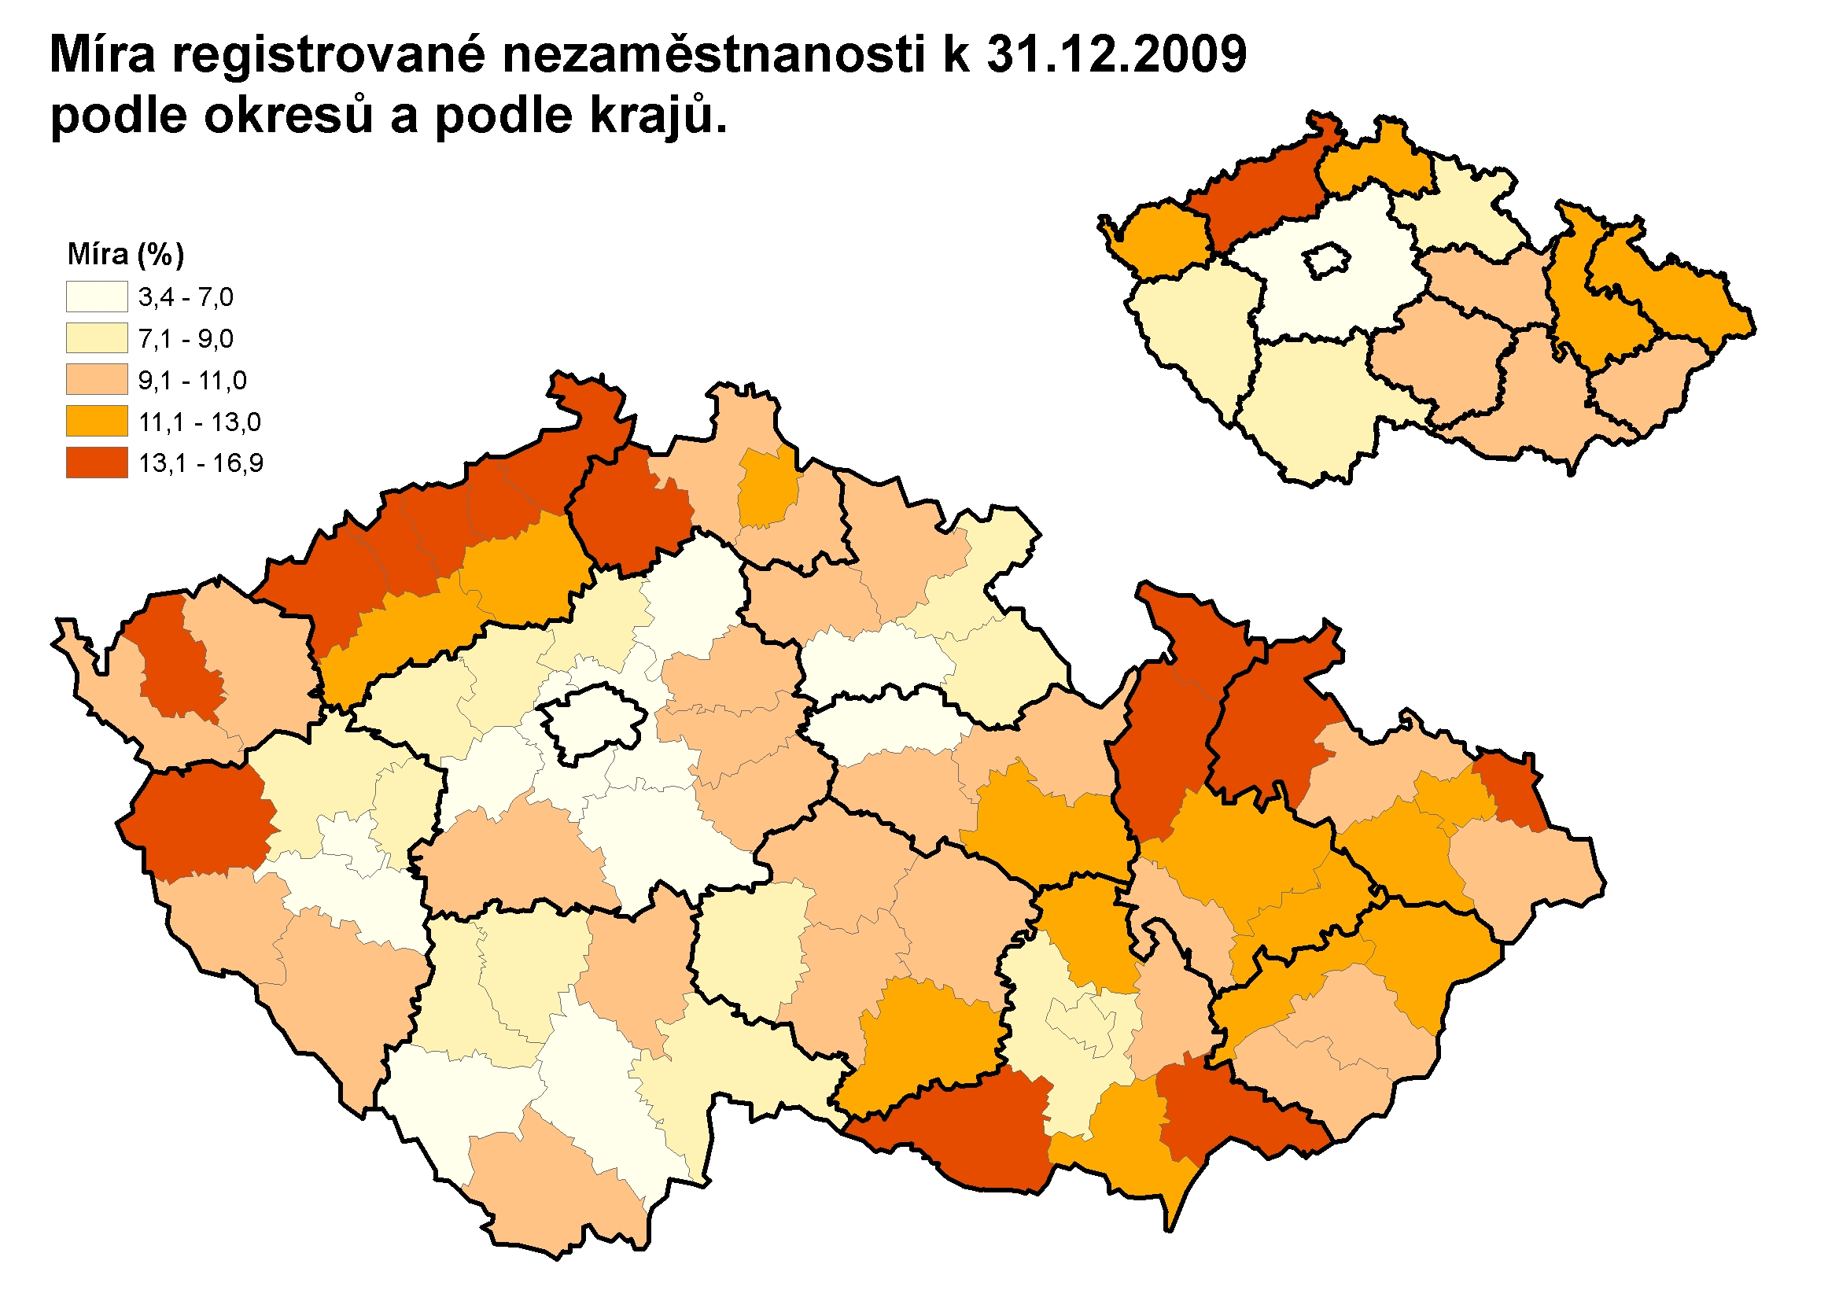Source: Ministry of Labour and Social Affairs
Registered unemployment rate as per December 31st, 2009
by districts and by regions

Employment and unemployment figures according to Labour Force Sample Survey (LFSS).
Figures according to labour statistics.
According to the structural labour statistics of the Ministry of Labour and Social Affairs.

